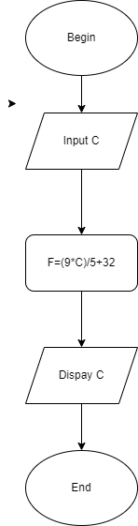BEGIN

INPUT C

F=(9\*C)/5+32

DISPLAY C

END